Virtual Internship 6.0 
Infosys Springboard Virtual Internship 6.0 Completion Report
AirAware
Batch Number: 6
Start date: 10-11-2025
Team Details:
Team-A
- Rajalakshmi
- Jampana Rahul Varma
- N N Sai Sreya
- Divija Nandana
- Lokesh

Internship Duration: 40 days(12 weeks)

Virtual Internship 6.0
Project Title:
AirAware: Smart Air Quality Prediction System
Project Objectives:
The primary objective of the AirAware: Smart Air Quality Prediction System is to design and implement an AI-driven platform that predicts future air quality levels and presents actionable environmental insights to users.
The key objectives of the project include:
- Predict future air quality metrics, particularly PM2.5 concentrations, using machine learning models.
- Enable proactive health and environmental decision-making through accurate AQI forecasting.
- Provide interactive visualizations that simplify complex environmental data.
- Offer explainable AI outputs to help users understand predictions and pollution trends.
- Assist individuals and communities in planning outdoor activities and health precautions based on predicted air quality levels.
Project Description:
AirAware is an end-to-end intelligent air quality prediction system that integrates data analytics, machine learning, backend services, and frontend visualization into a unified platform.
The system utilizes historical air quality datasets consisting of particulate matter (PM2.5, PM10), gaseous pollutants (NO₂, SO₂, CO, O₃), and temporal metadata such as date, time, and location. These datasets are preprocessed to remove inconsistencies, handle missing values, and normalize features to ensure reliable model training.
A machine learning pipeline was developed to forecast future PM2.5 concentrations. Multiple models were trained and evaluated, with the Random Forest model emerging as the best performer due to its ability to capture non-linear relationships among pollutants and temporal patterns.
The backend of the system was implemented using FastAPI, providing high-performance RESTful APIs for predictions, data retrieval, and analytics. The frontend was developed using React, offering an interactive dashboard that visualizes AQI levels, pollutant breakdowns, and prediction trends through charts and indicators.
An AI-powered chatbot was integrated using large language models to explain pollutant impacts, AQI categories, and health recommendations in a user-friendly manner. The system also supports user authentication and data storage using Supabase.
Overall, AirAware transforms static air quality data into predictive intelligence, empowering users with timely and interpretable environmental insights.

Virtual Internship 6.0
Timeline Overview:
Week | Activities Planned | Activities Completed
Week 1 | Problem identification, domain study on air pollution | Air quality challenges analyzed, project scope and objectives finalized
Week 2 | Dataset exploration and feasibility study | Historical air quality datasets identified and collected
Week 3 | Data cleaning and preprocessing planning | Missing values handled, outliers removed, data normalized
Week 4 | Feature engineering and target variable selection | Temporal features, lag variables, and rolling averages created
Week 5 | Machine learning model selection and experimentation | Multiple ML models implemented and trained
Week 6 | Model evaluation and optimization | Random Forest selected as best model with optimized performance
Week 7 | Backend architecture planning and API design | FastAPI backend setup and prediction endpoints implemented
Week 8 | Frontend UI wireframe and dashboard design | React dashboard developed with charts and AQI indicators
Week 9 | ML model integration with backend and frontend | End-to-end prediction flow successfully integrated
Week 10 | Visualization enhancement and report generation | Pollutant breakdown, AQI classification, and downloadable reports implemented
Week 11 | AI chatbot integration and testing | Chatbot added for AQI explanation and health recommendations
Week 12 | System testing, documentation, and final review | Full system validated, report completed, project ready for submission

System Architecture:
The AirAware system follows a modular architecture consisting of the following components:
- Data Collection Layer
- Historical air quality datasets
- Pollutant concentration records and AQI values
- Machine Learning Layer
- Feature engineering (temporal features, lag variables, rolling averages)
- Model training, evaluation, and selection
- Backend API Layer
- FastAPI-based REST endpoints
- Model inference and data processing
- Frontend Dashboard Layer
- React-based interactive visualization
- User inputs, charts, reports, and insights
This architecture ensures scalability, maintainability, and seamless integration between prediction logic and user interaction.

Virtual Internship 6.0
Technology Stack:
The following technologies were used in the development of AirAware:
- Frontend: React – Interactive and responsive dashboard
- Backend: FastAPI – High-performance API services
- Machine Learning: Scikit-learn – Model training and evaluation
- Database & Auth: Supabase – User credentials and data storage
- Visualization: Charts and real-time analytics components
- AI Chatbot: LLM integration using OpenAI API
Data Collection and Preparation:
Dataset Composition
The dataset includes:
- PM2.5 and PM10 particulate matter concentrations
- Gaseous pollutants such as NO₂, SO₂, CO, and O₃
- Temporal features including date and time
- Location-based air quality metadata
- Historical AQI values
Preprocessing Pipeline
The raw environmental data undergoes systematic preprocessing steps including:
- Removal of outliers and erroneous readings
- Handling of missing values
- Feature normalization using standard scaling
- Selection of PM2.5 concentration as the target variable due to its strong health impact
Machine Learning Pipeline:
The machine learning workflow consists of the following stages:
- Feature Engineering
- Extraction of time-based features (hour, day, month)
- Creation of lag features and rolling averages
- Train-Test Split
- Chronological splitting (80% training, 20% testing) to preserve temporal consistency
- Model Training
- Training multiple regression models with hyperparameter tuning
- Evaluation and Selection
- Performance comparison using R², Mean Squared Error (MSE), and Root Mean Squared Error (RMSE)
Frontend Design and Implementation
The frontend of AirAware is developed using React.js to build a dynamic and responsive user interface. The project is scaffolded using Vite, which provides faster development builds and optimized performance.
Virtual Internship 6.0

The user interface design is implemented using HTML and CSS, with Tailwind CSS utilized for utility-based styling to ensure a clean, responsive, and consistent layout across different screen sizes.
The frontend is responsible for:
- User authentication (login and signup) through Supabase
- Displaying air quality parameters and predicted values
- Visualizing pollution trends and AQI-related insights
- Sending user requests to the backend APIs and rendering responses in real time
React’s component-based architecture enables modular development and easier maintenance of the user interface.
Backend Architecture
The backend of AirAware is implemented using a hybrid architecture involving Python and Node.js.
- Python :
The Python backend handles the machine learning model execution and prediction logic. It exposes RESTful API endpoints that receive processed input data from the frontend and return predicted PM2.5 values.
- Node.js :
Node.js is used to manage frontend development services and client-side routing. It supports efficient communication between the React frontend and backend services during development.
This separation allows efficient handling of both machine learning operations and application-level interactions.
Database and Authentication
Supabase is used for both database management and user authentication.
- Authentication:
Supabase provides secure authentication using email and password, enabling controlled access to the AirAware application.
- Database:
Supabase stores:
  - User profile information
  - Historical air quality data
  - Prediction results and timestamps
  - Application metadata
Supabase offers a scalable PostgreSQL-based backend with real-time data access and seamless integration with the React frontend.
Virtual Internship 6.0

API Design and Communication
The application uses Python-based REST APIs to facilitate communication between the frontend and the machine learning model.
- APIs accept air quality parameters and temporal features as input
- Preprocessing steps are applied before prediction
- The trained machine learning model generates PM2.5 predictions
- Predicted values are returned to the frontend in JSON format
This API-driven approach ensures loose coupling between the frontend and the machine learning components, improving system flexibility and maintainability.
Machine Learning Model Integration
The trained machine learning model is integrated into the application using Python.
- The model is loaded within app.py
- Incoming data from the frontend is preprocessed using the same pipeline applied during training
- The model predicts PM2.5 concentration, which is used to compute AQI levels
- Results are sent back to the frontend for visualization and analysis
This integration ensures consistency between training and inference while enabling real-time air quality prediction.

Execution Details:
The execution of the AirAware system followed a structured and iterative development approach.
The project began with requirement analysis and domain research to understand air pollution challenges and the limitations of existing monitoring systems. Suitable historical air quality datasets were identified and analyzed for feasibility.
Data preprocessing was performed to clean raw environmental data, handle missing values, remove outliers, and normalize features. Feature engineering techniques such as temporal feature extraction, lag features, and rolling averages were implemented to enhance model performance.
Multiple machine learning models were trained and evaluated using performance metrics such as R², Mean Squared Error (MSE), and Root Mean Squared Error (RMSE). The Random Forest model was selected due to its superior accuracy and robustness.
The backend was developed using FastAPI to expose prediction and data APIs. The trained ML model was integrated into the backend for real-time inference. The frontend dashboard was developed using React, enabling users to visualize AQI levels, pollutant distributions, and prediction trends interactively.
Virtual Internship 6.0

An AI chatbot was integrated to provide explainable AI features, helping users understand AQI values, pollutant impacts, and health precautions. The system was tested iteratively to ensure accuracy, usability, and stability before final documentation and submission.

Project Milestones:
Milestones | Dates | Description | Progress
Inauguration | 10-11-2025 | Defined objectives, scope, and workflow | 0%
Milestone-1 | 20-11-2025  21-11-2025 | Completed basic frontend structure | 25%
Milestone-2 | 4-12-2025  5-12-2025 | Trained and selected optimal ML model | 50%
Milestone-3 | 18-12-2025  19-12-2025 | Backend and ML integration | 75%
Milestone-4 | 30-12-2025  31-12-2025 | Completed system with documentation | 100%

Virtual Internship 6.0
Screenshots:
Login Page:
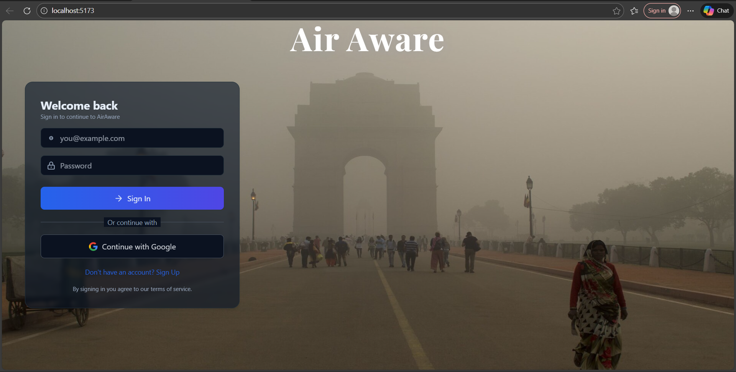
Dashboard(Light Mode):
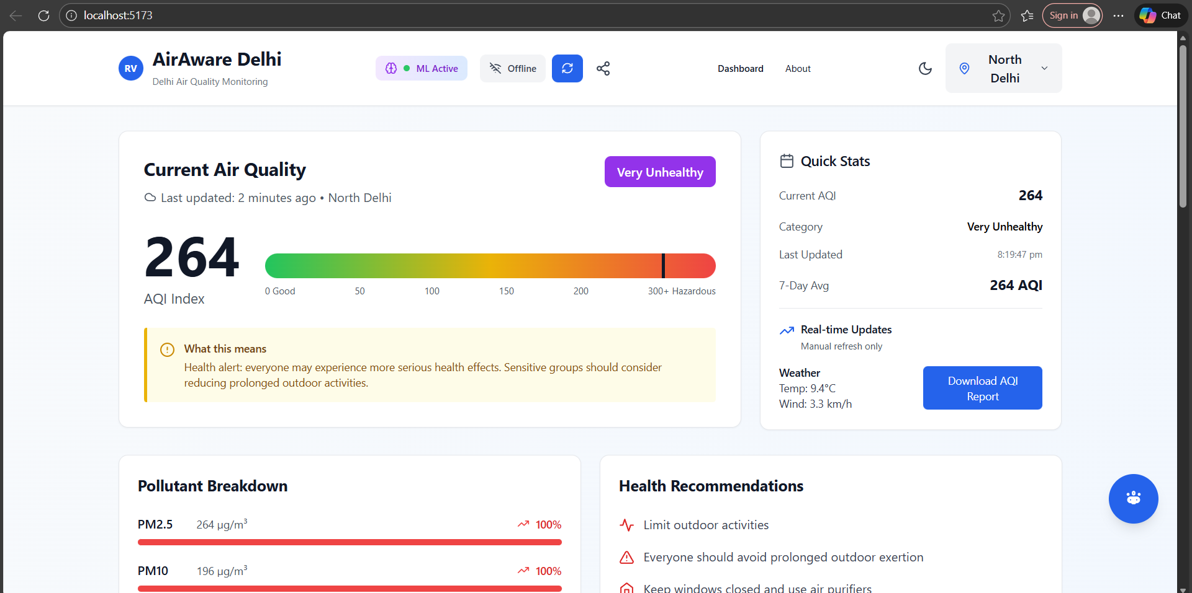

Virtual Internship 6.0 Dashboard(Dark Mode):
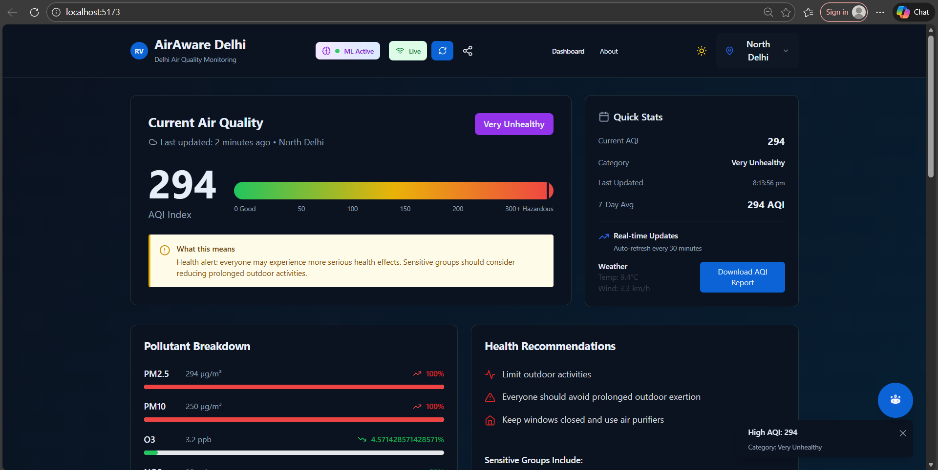
Pollutant Breakdown and Health Recommendations:
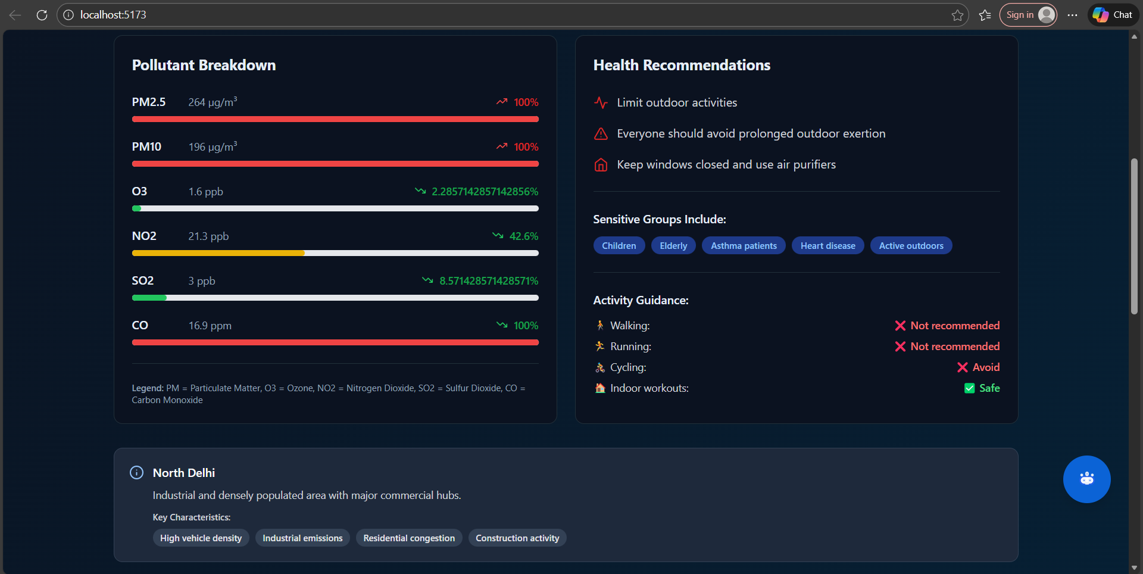

Virtual Internship 6.0
ML Model Integration:
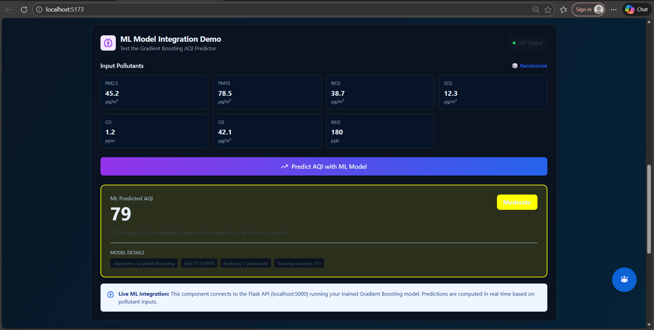
About Page:
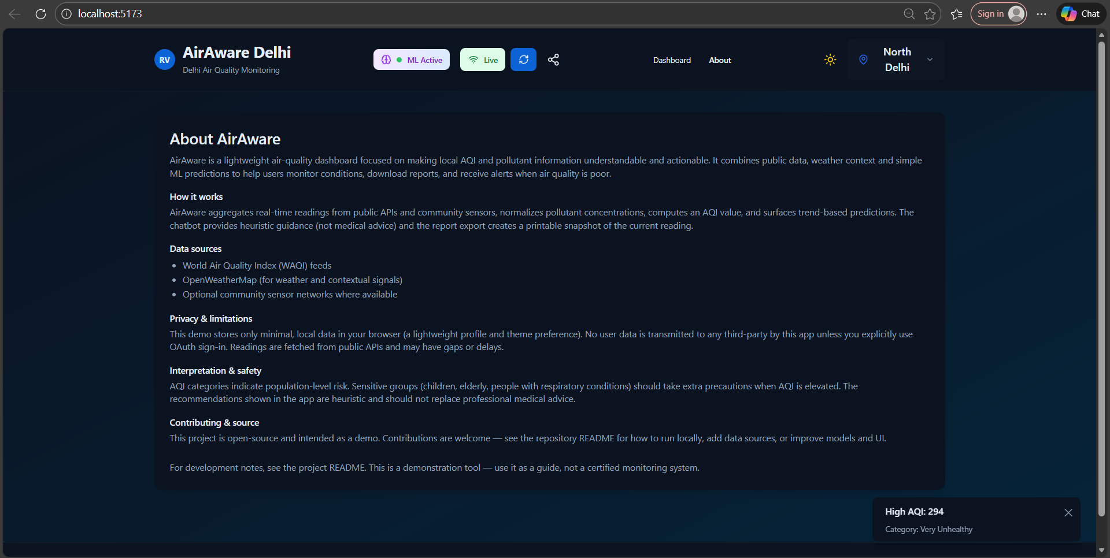

Virtual Internship 6.0
Profile Page:
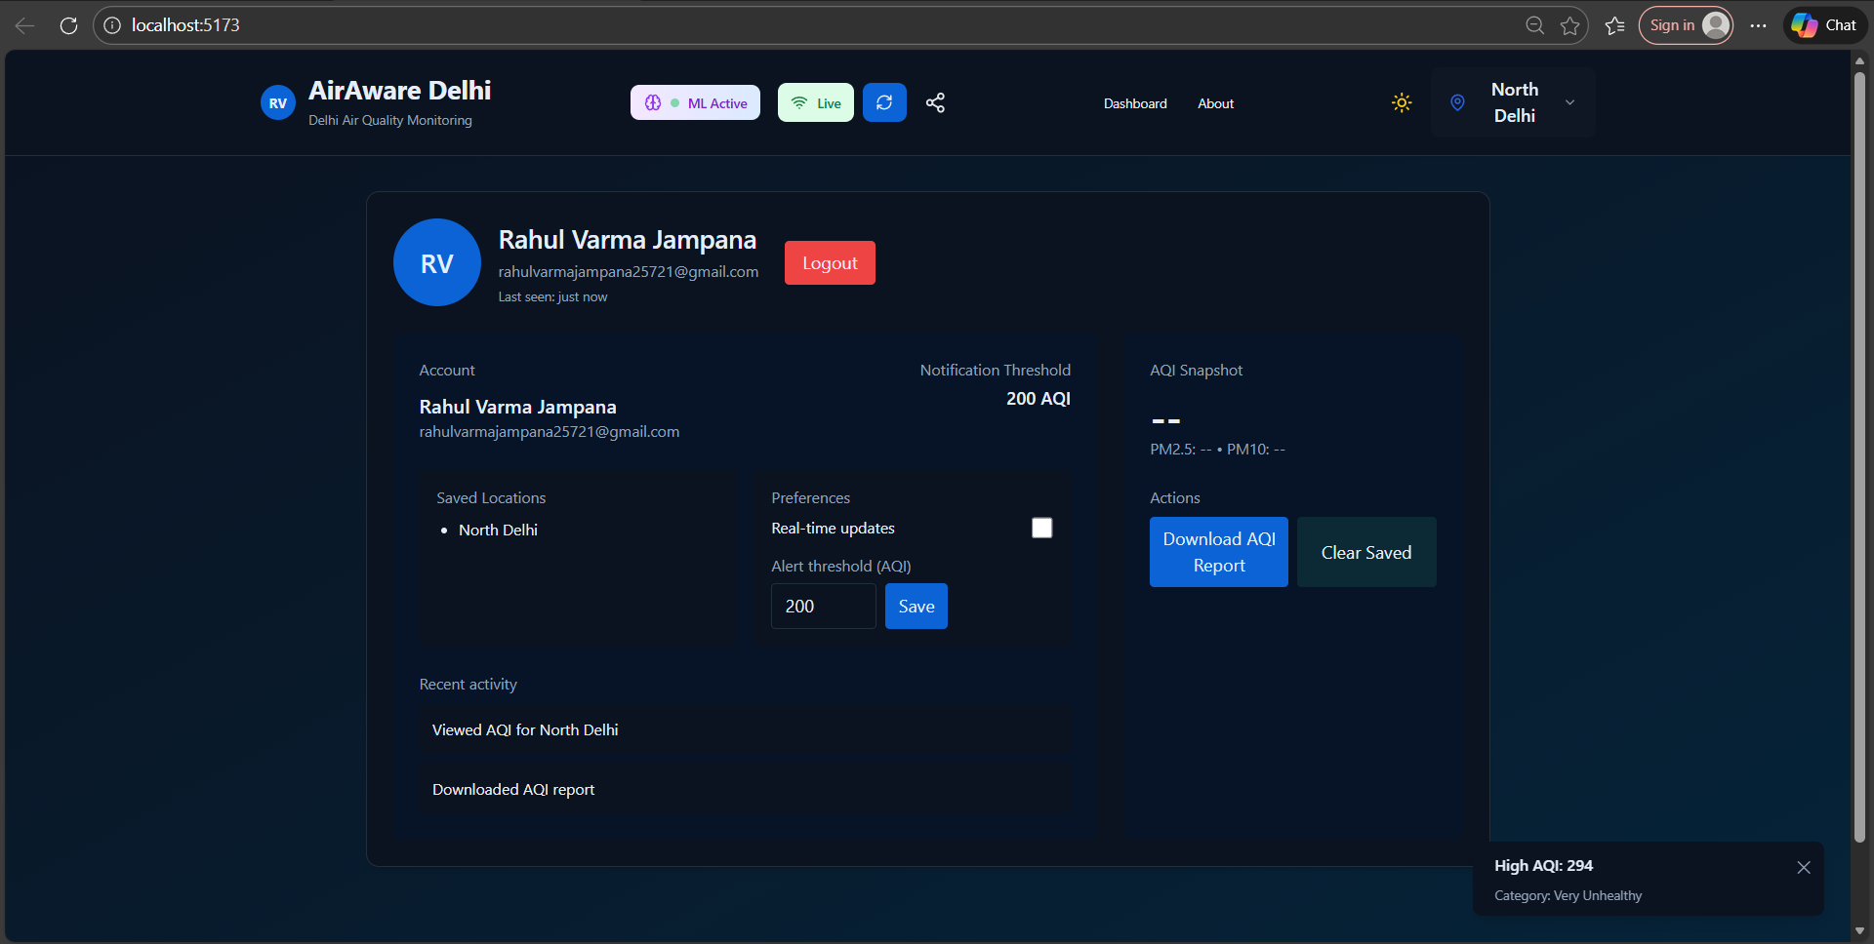
AQI Report:
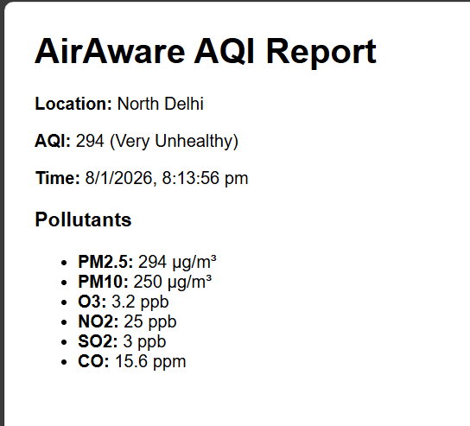

Virtual Internship 6.0
Chatbot:

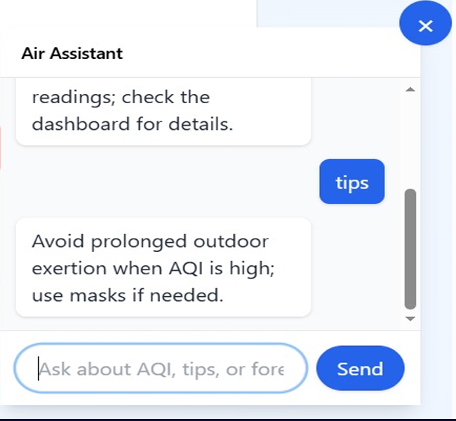

Challenges Faced:
During the development of AirAware, the following challenges were encountered:
- Handling missing and inconsistent air quality data
- Capturing temporal dependencies without data leakage
- Selecting the optimal machine learning model
- Integrating ML predictions with real-time APIs
- Designing intuitive visualizations for complex environmental data
- Ensuring chatbot responses were accurate and user-friendly
These challenges were resolved through iterative testing, model tuning, and UI refinement.

Virtual Internship 6.0
Learnings & Skills Acquired:
- Environmental data analysis and preprocessing
- Machine learning regression and ensemble methods
- Feature engineering for time-series data
- Backend development using FastAPI
- Frontend dashboard development using React
- API-based ML deployment
- Explainable AI and chatbot integration
- Technical documentation and reporting
Testimonials from team:
Team Member 1
“Working on the Air Aware Smart Air Quality Predicting System gave me invaluable experience in building a real-world full-stack application focused on environmental data. I was actively involved in developing features that collect, process, and display air quality information, which strengthened my skills in both backend logic and frontend visualization. This project deepened my understanding of how modern applications interact with data and make it meaningful for users. By tackling real-time predictions and integrating various system components, I gained confidence in delivering an end-to-end solution that addresses a practical, socially relevant problem.”
Team Member 2
“This project provided valuable exposure to full-stack development and the integration of machine learning models with backend APIs. Designing and visualizing air quality insights helped me understand the importance of presenting complex data in a clear and user-friendly manner.”
Team Member 3
“This project helped me gain strong hands-on experience in frontend development and database integration. I worked on designing user-friendly interfaces for data visualization and ensuring smooth interaction between the frontend and backend systems. Integrating the database with the application improved my understanding of data flow, storage, and retrieval in real-world projects. Overall, the project strengthened my technical skills and boosted my confidence in building complete, functional systems.”
Team Member 4
“Working on the AirAware project during this virtual internship was a great learning experience. Being part of a group project helped me understand how real-world applications are built collaboratively. I worked on database management using Supabase, where I handled data storage and supported backend integration. Even in a virtual setup, our team communicated well, supported each other, and learned together. This project improved my technical skills and gave me confidence in working as part of a team”

Virtual Internship 6.0
Team Member 5
“Contributing to the Air Aware Smart Air Quality Predicting System allowed me to gain practical experience in building a real-world, full-stack application with a strong focus on environmental impact. I played an active role in designing and implementing features that collect, process, and visually present air quality data, which strengthened my expertise in backend development and frontend visualization techniques.
This project significantly improved my understanding of how modern systems manage data pipelines and transform raw information into meaningful insights for users. By working with real-time air quality predictions and ensuring seamless integration between various system components, I gained confidence in delivering a complete end-to-end solution that addresses a practical and socially relevant challenge.”
Conclusion:
The AirAware: Smart Air Quality Prediction System successfully demonstrates the application of machine learning and data visualization in addressing real-world environmental challenges. By transforming historical air quality data into predictive insights, the system enables users to take proactive health and lifestyle decisions.
The project strengthened the team’s skills in end-to-end system development, machine learning deployment, and user-centric application design. AirAware stands as a scalable and impactful solution with potential for future enhancements such as real-time sensor integration, mobile applications, and advanced forecasting techniques.
Acknowledgements:
We express our sincere gratitude to Infosys Springboard for providing the opportunity to work on this project and for offering a structured learning environment with industry-relevant resources.
We also thank our mentor Ms. Shakthi Gopalakrishnan for her continuous guidance, feedback, and support throughout the project lifecycle. Her insights played a vital role in refining our approach and enhancing our learning experience.

